 | 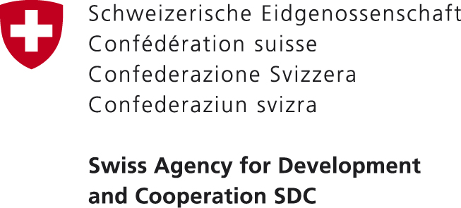 | 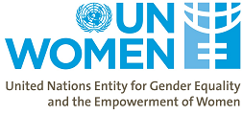

Gender Pay Gap – Measurement and Policy Implications

Tbilisi, Holliday Inn, 2 October 2018, 15:00 o’clock

AGENDA
14:30 – 15:00 Welcome coffee / participants’ registration

Meeting facilitated by Dimitri Tskitishvili, Deputy Chair of Foreign Relations’ Committee of the Parliament of Georgia, Member of Gender Equality Council of the Parliament

15:00 – 15:20 | Opening Remarks  Tamar Chugoshvili, Vice-Speaker of the Parliament, Chair of Gender Equality Council of the Parliament  Erika Kvapilova, UN Women Country Representative in Georgia
15:20 – 15:50 | Status Quo – Gender Pay Gap Measurement Methodology and Data in Georgia  Paata Shavishvili, Deputy Chair of GEOSTAT  International Best Practices for Measuring Gender Pay Gap  Jessica Gardner, International Consultant on Gender Data, UN Women
15:50 - 16:30 | Discussion
16:30 – 16:45 | Coffee-break
16:45 – 17:30 | Brainstorming on Policy Measures to Reduce Gender Pay Gap  Tamar Barkalaia, Deputy Minister of Internally Displaced Persons from the  Occupied Territories, Labour, Health and Social Affairs of Georgia  Ekaterine Mikabadze, Deputy Minister of Economy and Sustainable Development  Kinan Bahnassi, Chief Technical Advisor, ILO
17:30 – 18:10 | Discussion
18:10 – 18:30 | Closing remarks and action points

List of invitees:

- GEC
- Inter-agency Commission on GE, EVAW and DV
- SDG Secretariat
- HR Secretariat
- Ministry of Economy – Labour Force Survey colleagues
- PDO
- Trade Union
- Employers’ Association
- ILO
- UNDP
- UNFPA
- SDC
- NDI
- GGI
- EMC
- GYLA
- Progressive Forum
- Solidarity Center
- Friedrich Ebert Stiftung
- Article 42
- Partnership for Human Rights
- Solidarity Network
- Women’s Information Centre
- Georgian small and Medium Enterprises Association
- Business Association of Georgia
- European Business Association
- American Chamber of Commerce in Georgia
- Business Ombudsman of Georgia
- Sapari

